**ADT Requirements from Soarian to TRACE**

**Version 1.2**

**Prepared By: Tom Fredrickson**

**Date: 12/11/2017**

Document Control 3

Resources 3

Project Distribution List 3

Document Version Control 3

1. Introduction 4

1.1 Purpose 4

1.2 Project Scope 4

1.3 Terminology Standards 4

1.3.1 Acronyms 4

1.3.2 Glossary 4

1.4 Document References 5

2*.* Diagram 5

3. Requirements 6

3.1 Functional Requirements 6

3.2 Non-Functional Requirements 6

3.3 Messaging Protocols 6

3.3.1 Inbound to BayCare Cloverleaf 6

3.3.2 Outbound to Trace 7

4. HL7 Messaging 7

4.1 Messaging Format 7

4.1.1 Segments 7

4.1*.*2 Messaging Event Types 8

4.1*.*3 Cloverleaf Configuration Files 8

4.1.4 Cloverleaf Site Location 9

4.2 Data Transformation Requirements 9

4.3 Sample Message 10

5. Testing 12

5.1. Unit Testing Scenarios 12

5.2 Integrated Testing Scenarios 12

5.3 Testing Approvals 12

5.4 Piloting 13

5.5 Approvals 13

6. Deployment / Implementation Model 13

6.1 Alerts 13

Appendix A: Risks and Concerns 14

Appendix B: Issues List 14

# **Document Control**

## Resources

|  |  |  |
| --- | --- | --- |
| **Name** | **Role** | **Email** |
| Brenda More | BayCare IS Project Manager | Brenda.more@baycare.org |
| Wesley Thompson | Manager Training & Support CBO | Wesley.thompson@baycare.org |
| Rachel Silvan | Vendor Project Manager | Rachel.silvan@twsg.com |
| Tom Fredrickson | BayCare Integration Analyst | Thomas.fredrickson@baycare.org |
| Tom Skoda | Vendor Technical Specialist | Tom.skoda@twsg.com |
| Derek Morgan | Vendor Interface Lead & Project Owner | Derek.morgan@twsg.com |
|  |  |  |
|  |  |  |

## Project Distribution List

## Document Version Control

|  |  |  |  |
| --- | --- | --- | --- |
| **Version** | **Date** | **Modifier** | **Description** |
| V1.0 | 5/17/2016 | Lois Whitley | Originally Created |
| V1.1 | 6/3/2016 | Tom Fredrickson | Tech Updates |
| V1.2 | 12/11/2017 | Tiffany Bohall | Added filter to the route which suppress all transactions from the Soarian BOI feed where MSH.3 is MDC. |
|  |  |  |  |

# 1. Introduction

## 1.1 Purpose

The purpose of this document is to outline the Admission, Discharge and Transfer (ADT) interface requirements for the TRACE application. This is a one-way interface from Soarian to TRACE with Patient Demographic Information.

## 1.2 Project Scope

The Central Business Office (CBO) is looking to improve and enhance their current workflow processes at both East and West Central Authorization Units (CAU) and Imaging Scheduling Call Center (East-Tampa & West-Dunedin). With the implementaion of new TRACE modules and updating the existing Enterprise TRACE system will allow the CBO to expand and use the TRACE system in other departments that handle patient access services, patient financial obligations and denial management.

Business Objectives/Benefits include:

* Implement inbound and outbound FAXing with workflow processes
* Establish ability to record inbound and outbound telephone calls
* Move from current StaffWare workflow system to TRACE solution for all BayCare Central Authorization Units (CAUs) and Central Scheduling
* Implement PixCert in CAU East/West and Imaging Scheduling Call Center

## 1.3 Terminology Standards

### 1.3.1 Acronyms

**ADT** – Admission Discharge, Transfer

**CAU** – Central Authorization Unit

**CBO** – Central Business Office

**ISCC** – Imaging Scheduling Call Center

### 1.3.2 Glossary

**FaxCert** - facilitates electronic faxing – eliminating the need to print, scan and manually fax documents. The tool automatically captures both inbound and outbound faxes, along with details such as sender/recipient, date/time and proof of receipt. Faxes are digitized, indexed by patient and available for retrieval and routing through Trace. Alerts provide notice of new faxes, unsuccessful transmission and delivery confirmation

**PixCert -** offers the ability to capture web pages, patient records, scanned documents and images through any web-enabled PC. The tool captures activities performed through web sites, electronic documents and emails. Captured images are indexed and can be routed through Trace or electronically faxed to any outside party

**Tracker** - an intuitive web interface of voice, fax and electronic communication. Records are indexed by patient and other custom criteria for easy search, sort, delivery and retrieval.

## 1.4 Document References

BayCare TWSG Technical Kick Off

TWSG ADT Interface Specification

Project Definition and Scope Document Trace Solution

Soarian ADT Interface to Trace

# 2*.* Diagram

Provide a solution diagram that depicts the integration of components specified in this IDBB. This diagram must include the data flow for the interfaces (source and target).

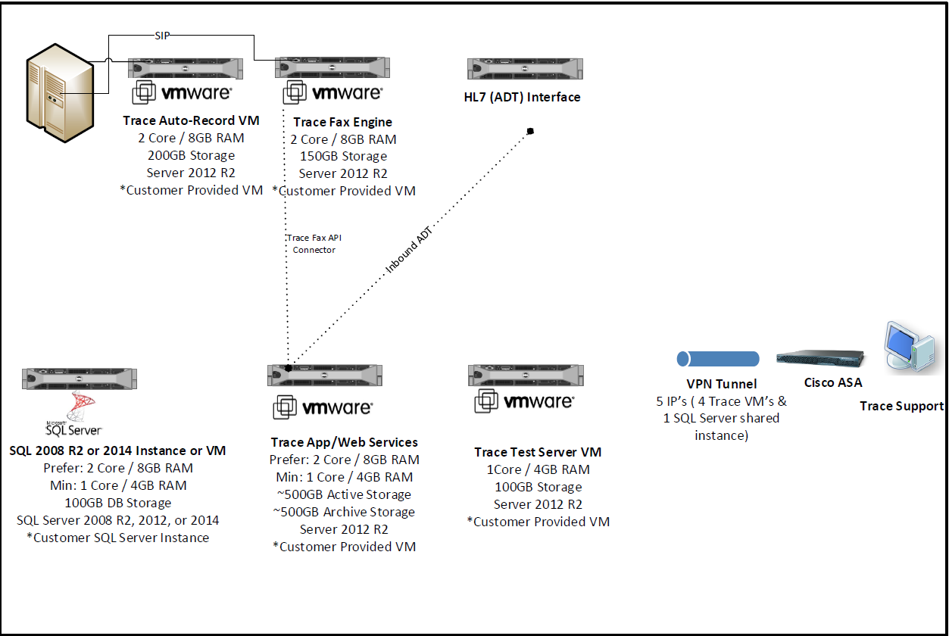

# 3. Requirements

## 3.1 Functional Requirements

|  |  |  |
| --- | --- | --- |
| **Cloverleaf** |  |  |
| **Number** | **Requirement Name** | **Requirement Description** |
| FR.20XX.1.0 | Soarian ADT: BOI Codes. | Using a Cloverleaf Table to populate the BOI facility codes. |

## 3.2 Non-Functional Requirements

|  |  |  |
| --- | --- | --- |
| **Cloverleaf** |  |  |
| **Number** | **Requirement Name** | **Requirement Description** |
| NFR.2017.12.11 | Suppressing MDC location | Added filter to the route which suppress all transactions from the Soarian BOI feed where MSH.3 is MDC. |

## 3.3 Messaging Protocols

Below are listed the details for the messaging protocols that will be leveraged for this integration. Please see the reference document located on the Integration SharePoint server: [TWSG ADT Interface Specification](http://bcspapp01:48601/sites/SecurityDataIntegrity/EnterpriseIntegration/team/Shared%20Documents/Projects/TRACE/TWSG%20ADT%20Interface%20Specification.pdf)

**Cloverleaf Sites: Production 🡪 soarf_adt_ent_18 Test 🡪 soarf_adt_ent_18**

### 3.3.1 Inbound to BayCare Cloverleaf

|  |  |  |
| --- | --- | --- |
| **Facility Code** | **Facility Name** | **Port** |
| MPH | Morton Plant | 5149 |
| MCS | Mease Countryside | 5150 |
| MDU | Mease Dunedin | 5151 |
| NBY | Morton Plant North Bay | 5152 |
| BAH | BayCare Alliant | 5153 |
| SJH | St. Joseph's | 5154 |
| SJN | St. Joseph's Hospital-North | 5155 |
| SJS | St. Joseph's Hospital-South | 5156 |
| SFB | South Florida Baptist | 5157 |
| SAH | St. Anthony's | 5158 |
| SJW | St. Joseph's Women's | 5159 |
| WHH | Winter Haven | 5160 |
| BOI | BayCare Outpatient Imaging | 5161 |
| BRM | Bartow Regional Medical Center | XXXX |

### 3.3.2 Outbound to Trace

Test

The test server is the same as production. The east and west feeds are disabled using port # 9999.

IP Address: 10.44.0.101

Port Number: 9999 trace_west_adt_out

Port Number: 9999 trace_east_adt_out

Port Number: 5147 trace_boi_adt_out

Prod

IP Address: 10.44.0.101

Port Number: 6170 trace_west_adt_out

Port Number: 6171 trace_east_adt_out

Port Number: 6161 trace_boi_adt_out

# 4. HL7 Messaging

## 4.1 Messaging Format

* Soarian ADT messages follow HL7 variant version 2.6, Soarian ADT_A01

### 4.1.1 Segments

The segments utilized for this interface are:

Message Segments **(Bold denotes required)**

* + **MSH Message Header**
  + EVN Event Type
  + **PID Patient Identification**
  + **PV1 Patient Visit**
  + DG1 Diagnosis Information
  + IN1 Insurance Information
  + GT1 Guarantor Information
  + PD1 Additional Demographic Information
  + PV2 Additional Visit Information

Trace will disregard the segments and fields that are not utilized within the product. There is no need to filter the unused segments within the hospital interface engine. Trace will filter these by default.

*Message Construction Notes:*

*[Square Brackets] – Optional*

*{Curly Brackets} – Repeatable*

*MSH – Message Header*

*EVN – Event segment*

*PID – Patient ID segment*

*PV1 – Patient Visit segment*

*ORC – Common Order segment*

*IN1 – Insurance segment*

*[{ – Start of optional, repeatable group*

*}] – End of optional, repeatable group*

### 4.1*.*2 Messaging Event Types

Below are the messages types necessary for this integration

|  |  |
| --- | --- |
| **Event Type** | **Description** |
| A01 | Admit Patient |
| A02 | Transfer Patient |
| A03 | Discharge Patient |
| A04 | Register Patient |
| A05 | Pre-Admit Patient |
| A08 | Update Patient Information |
| A28 | Add Person Information |
| A31 | Update Person Information |

### 4.1*.*3 Cloverleaf Configuration Files

The hospital routes use the **soarf_trace_adt.xlt** Xlate file to filter the feed.

The BOI route uses a filter chain of **soarf_adt_norm.xlt** and then **soarf_trace_adt.xlt**.

### 4.1.4 Cloverleaf Site Location

This interface resides in the misc4 site. There are ADT feeds coming from 12 BayCare facilities: MPH, MCS, NBY, MDU, BAH, SJH, SJN, SJS, SFB, SAH, SJW, WHH. The inbound feeds are routed into 3 outbound threads. An East and a West region with a separate thread for BOI facilities (BayCare Outpatient Imaging).

These routes have the following naming convention:

soarf_xxx_adt_in 🡪 trace_west_adt_out

Where xxx is the facility abbreviation.

East region facilities: SJH, SJN, SJS, SFB, SJW, WHH

soarf_xxx_adt_in 🡪 trace_east_adt_out

West region facilities: MPH, MCS, NBY, MDU, BAH, SAH

These connections are sending ADT A01 A03 A04 A05 A08 messages.

There is also a BayCare Outpatient Imaging feed (BOI).

soarf_boi_xfer 🡪 trace_boi_adt_out

This connection is sending ADT A02 A03 A04 A05 A08 A028 A031 messages

## 4.2 Data Transformation Requirements

For BOI messages ( MSH-4 Sending Facility = BOI ) there is a check to see it the PV2–23.6.1 Assigning Authority has a value of 900000. If this is true a table lookup is made using the PV2-23.3 Organization ID field to fill in the MSH-4 Sending Facility code value using the following table:

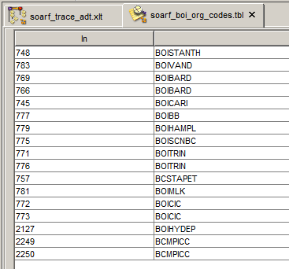

Please consult the following Xlate file for details of the transformation: **soarf_trace_adt.xlt**

## 4.3 Sample Message

Example Outbound Soarian ADT Interface Message to Trace

**Admissions, Discharges and Transfers (ADT) Interface – Message Segments Used:**

| Message Segment | Description | # | | Fields Included in Segment (Passed to Trace) | |
| --- | --- | --- | --- | --- | --- |
| MSH | Message Header  (Required) | 3 | | Sending Application (SOARIAN) | |
| 4 | | Sending Facility (BAYCARE) | |
| 5 | | Receiving Application (TRACE) | |
| 6 | | Receiving Facility | |
| 7 | | Date / Time of Message | |
| 9 | | Message Type^Trigger Event (ADT^A08) | |
| 10 | | Message Control ID | |
| 11 | | Processing ID (Defaulted to “P”) | |
| 12 | | Version ID | |
| MSH|^~\&|SOARIAN|BAYCARE|TRACE|MPH|201510231154||ADT^A08|195e5849-7670-4bac-bb48-981d6017c268|P|2.6 | | | | |  | | Trigger Event |
| EVN | Event | 1 | | Event Type Code | |
| 2 | | Date / Time of Event | |
| EVN|A08|201510231154 | | | | |  | | External Patient ID (Community MRN#) |
| PID | Patient Identification  (Required) | 2 | | External Patient ID (BCCPI) | |
| 3 | | Internal Patient ID (CPI) ~ Internal Patient ID (BCMRN) | |
| 5 | | Patient Name | |
| 7 | | Birth Date | |
| 8 | | Sex | |
| 10 | | Race | |
| 11 | | Patient Address ~ E-Mail Address | |
| 13 | | Phone Number – Home (This is the Primary Phone in Soarian) | |
| 18 | | Patient Account Number | |
| 19 | | Social Security Number - Patient | |
| PID|1|300146258^^^^BCCPI|300146258^^^^CPI~2104716517^^^^BCMRN||MOUSE^MINNIE^P||19681209|F||PcfIs|3986 TAMPA RD^^Oldsmar^FL^34677^^HOME~minnie@hotmail.com^^^^^^EMAIL||(727)867-5309|||||6000008930^^^^BCFN|123456789 | | | | |
| PV1 | Patient Visit | | 4 | | Admission Type | |
| 5 | | Pre-Admit Number | |
| 8 | | Referring Doctor | |
| 18 | | Patient Type | |
| 20.1 | | Financial Class | |
| 44 | | Admit Date / Time | |
| 45 | | Discharge Date / Time | |
| 50 | | Alternate Visit ID | |
| PV1||||Emergency||||||||||||||E||Auto Med | | | | | |
|

|  |  |  |  |
| --- | --- | --- | --- |
| IN1 | Insurance | 2 | Plan ID |
| 3 | Company ID |
| 4 | Company Name |
| 5 | Company Address |
| 7 | Company Phone # |
| 8 | Group Number |
| 9 | Group Name |
| 14 | Authorization Information |
| 15 | Plan Type |
| 16 | Name of Insured |
| 17 | Insured’s Relationship to Patient |
| 18 | Insured’s Date of Birth |
| 19 | Insured’s Address |
|  | 22 | Coord of Ben. Priority |
|  | 30 | Verification By |
|  | 36 | Policy Number |
|  | 43 | Insured’s Administrative Sex |
|  | 44 | Insured’s Employer’s Address |
|  | 45 | Verification Status |
| IN1||1465|1506|Auto|PO BOX 106134^^ATLANTA^GA^303486134||||Auto State Farm|9010^^^900000^XX^^20150720|WALMART^L^9010^^^900000^XX||||Liability|MOUSE^MINNIE^P|6|19671209|3986 TAMPA RD^^Oldsmar^FL^34677|||1||||||||||||||123456789 | | |
| DG1 | Diagnosis | 3.1 | Diagnosis Code |
| 4 | Diagnosis Description |
| 5 | Diagnosis Date/Time |
|  | 6 | Diagnosis Type – Such as Admitting, Final, and Working |
| DG1|6||S42.101A^Fracture of unsp part of scapula, right shoulder, init^ICD10-CM|||Fnl|||||||||5 | | |

# **5. Testing**

## 5.1. Unit Testing Scenarios

|  |  |
| --- | --- |
| **Scenario** | **Expected Result** |
|  |  |
|  |  |
|  |  |
|  |  |
|  |  |

## 5.2 Integrated Testing Scenarios

|  |  |
| --- | --- |
| **Scenario** | **Expected Result** |
|  |  |
|  |  |
|  |  |
|  |  |
|  |  |
|  |  |

## 5.3 Testing Approvals

|  |  |  |  |
| --- | --- | --- | --- |
| **Testing Phase** | **Date** | **Department** | **Team Member** |
| PH1.UNIT |  |  |  |
| PH1.INTEGRATED |  |  |  |

### 

## 5.4 Piloting

List the facilities and associated networks in scope for pilot testing.

## 5.5 Approvals

|  |  |  |  |
| --- | --- | --- | --- |
| **Testing Phase** | **Date** | **Department** | **Team Member** |
| PH1.0 |  |  |  |
|  |  |  |  |
|  |  |  |  |

# 6. Deployment / Implementation Model

This was a big bang roll out where ADT was turned on for all facilities except Bartow.

## 6.1 Alerts

Are you going to need alerting on this connection?

|  |  |
| --- | --- |
| Yes |  |
| No |  |

SUPPORT HOURS: Mon-Fri 6am-8pm, Sat 8am-3pm

Technical Internal Contact:

Mandi Benefield

Ph: 813.852.3415

David Schade

Ph: 813.852.3414

These two people along with the Integration team will receive alert emails when the queue is over 500.

They will contact TRACE support and notify that there is an ADT interface back up in Cloverleaf.

Vendor contact information (as last resort) can be accessed on the Cloverleaf Customer Contacts spreadsheet on the Integration SharePoint site: Cloverleaf Team Site: Downtime and DR: Cloverleaf Customer Contacts.

# Appendix A: Risks and Concerns

|  |  |  |  |  |  |  |  |  |
| --- | --- | --- | --- | --- | --- | --- | --- | --- |
| **Project Name** |  |  | | |  |  |  |  |
| **Number** | **Risk / Concern** | **Comment** | **Mitigation** | | |  |  |  |
| RC.2013.1.0 |  |  | |  | |  |  |  |

# Appendix B: Issues List

This is a dynamic list of the open issues related to the IDBB that remain to be solved, including but not limited to TBDs, pending decisions, information needed, conflict awaiting resolution, and the like.

|  |  |  |  |  |  |  |  |  |
| --- | --- | --- | --- | --- | --- | --- | --- | --- |
| **Project Name** |  |  | | |  |  |  |  |
| **Number** | **Issue** | **Comment** | **Fix** | | |  |  |  |
| I.2013.1.0 |  |  | |  | |  |  |  |

* End of document